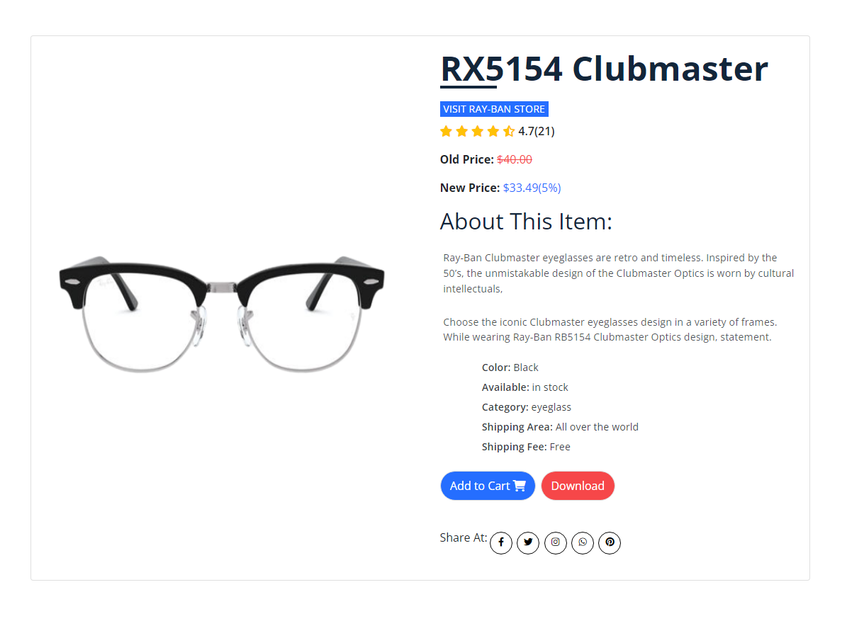
Ray-Ban Clubmaster eyeglasses are retro and timeless. Inspired by the 50’s, the unmistakable design of the Clubmaster Optics is worn by cultural intellectuals, those who lead the changed tomorrow.
Choose the iconic Clubmaster eyeglasses design in a variety of frames. While wearing Ray-Ban RB5154 Clubmaster Optics design, you’ll always make a statement.
Product Details

